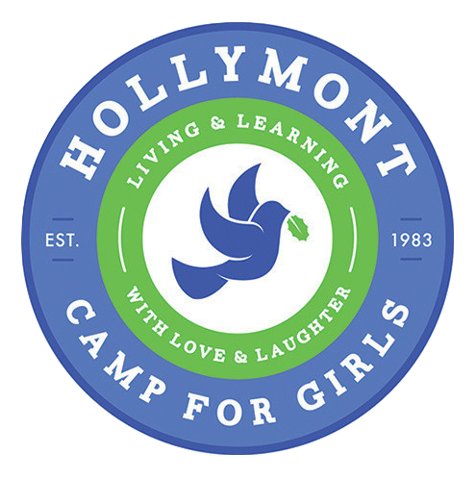

Dear Eagle 6 Campers & Families,
First and foremost, we hope this email finds you safe and healthy as we all continue to navigate through this unprecedented time. The cancellation of our 2020 camp season due to COVID-19 was disappointing for us all, but perhaps especially for our oldest girls who were looking forward to the privileges, traditions, and cherished memories of being the oldest campers. For years, campers return and look forward to this extra special Hollymont experience.
We have received numerous emails and social media messages from both campers and parents regarding options for this group of girls. Our tentative plan is to allow each camper (entering 10th grade for the 2020-2021 school year) to choose one of the following options for next summer: 1) Enroll as an Eagle 6 camper; or 2) Apply for a Counselor-in-Training position.
Our 2021 dates are now posted on our website and registration will be available in the next couple of weeks. If your daughter enrolls as a camper, we'll work extra hard to ensure this class enjoys all the "perks and privileges" of celebrating their last camper year. If your daughter chooses to apply to be a Counselor-in-Training, those (1st year CIT) applications will be posted on our website next month.
We'll continue to communicate updates and information as we begin planning for the summer of 2021 (aka: THE BEST SUMMER YET!). Our priority is for each camper and staff member to enjoy their time together in the "Hollymont Bubble" all while having FUN and strengthening their relationship with Jesus Christ. Thank you for all of your messages of encouragement during this time. We love you and can't wait to welcome back our Hollymont girls next summer!
Blessings,
Missy, Emily, and Gail

